Import Internal Transfer Invoice Workflow Functional Document

Application | NGERP - Centra
Workflow | Store To Shelf
Workflow Item Name | Import Internal Transfer Invoice

Description:

Internal Transfer Invoice in ERP is used to transfer of goods or services between different branches . The records value of transferred items for accounting purposes, ensuring accurate financial and inventory tracking of ITI Invoices.

Workflow Process:

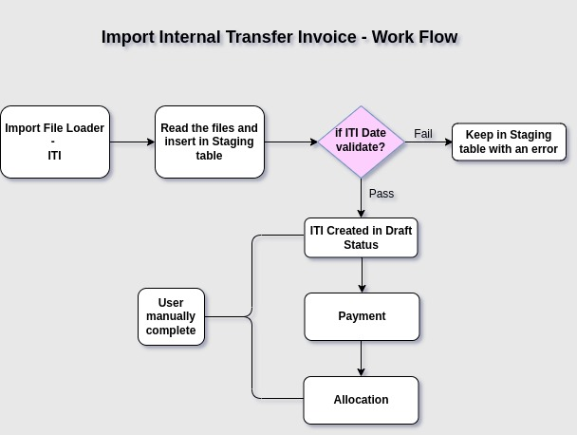

Business Rules:

- Import is purely for ITI creation from the Import File Loader.
- Import ITI used to document the transfer of goods or services between different branches.
- xlsx, csv file format only allowed to used Import ITI file used for file loader .
- After user process successfully completed in file loader , ITI data inserted into a temporary table(I_Invoice).
- Then validate and load the data is active Bpartner, product, qty, price.
- the validation process has succeeded, it insert records in Main table-(C_Invoice) user Process with draft status ITI or they are kept in the temp table, and an appropriate error message is provided.
- After complete the ITI manual by user in ITI screen.
- User create Payment – AR by manually or Import.
- User create/complete AR payment by manually .
- User allocate payment & invoice by user manually, once allocation completed View allocation created automatically by system.
- AR invoice after allocation completed paid check box ticked automatically by system.
- Payment – AR allocation completed allocated check box ticked automatically by system & allocation had created.

